Sales Data Analysis and Business Insights Report
Data Science Task #02 — Gexton Education Summer Internship Program
Prepared for: Sir Muhammad Arham MH

1. Objective
This report analyzes a small retail sales dataset (20 transactions across 12 products, 5 categories, and 4 regions, spanning January-June 2024) to demonstrate the full workflow of data cleaning, exploration, visualization, and business insight generation.

2. Dataset Overview
The raw dataset (sales_data_raw.csv) contains the following columns:
- OrderID — unique identifier for each transaction
- Date — date of the transaction (Jan-Jun 2024)
- CustomerID — identifier for the customer
- Product — name of the product purchased
- Category — product category (Electronics, Apparel, Furniture, Home Appliances, Stationery)
- Region — sales region (North, South, East, West)
- Quantity — units sold
- UnitPrice — price per unit (PKR)
- Revenue — total revenue for the row (Quantity x UnitPrice)
Initial exploration revealed several intentional data quality issues for cleaning practice: 1 duplicate row, 1 missing Quantity value, 1 missing UnitPrice value, 1 missing Region value, 1 negative Quantity value (data entry error), and inconsistent text casing in the Region column (e.g. 'south' vs 'South').

3. Data Cleaning Steps
- Removed 1 exact duplicate row using drop_duplicates().
- Standardized Region text casing using str.title() so 'south' and 'South' are treated as the same category.
- Converted the negative Quantity value to positive using abs(), assuming it was an entry error.
- Filled the missing Quantity value with the column median (robust to outliers).
- Filled the missing UnitPrice value using the median price for that specific product.
- Recalculated Revenue for all rows as Quantity x UnitPrice to ensure consistency after cleaning.
- Filled the missing Region value with the most frequent region (mode).
- Converted Date to datetime format and extracted Month and MonthNum columns for time-based analysis.
After cleaning, the dataset has 19 rows, zero missing values, and zero duplicates. The cleaned file is saved as sales_data_cleaned.csv.

4. Overall Sales & Revenue Trends
Key headline numbers (Jan-Jun 2024):
Metric | Value
Total Revenue | PKR 698,900.00
Total Orders | 19
Total Units Sold | 63
Average Order Value | PKR 36,784.21

The chart below shows revenue by month. January is the strongest month (driven by a large Laptop order), with revenue gradually declining through to June, the weakest month of the period.
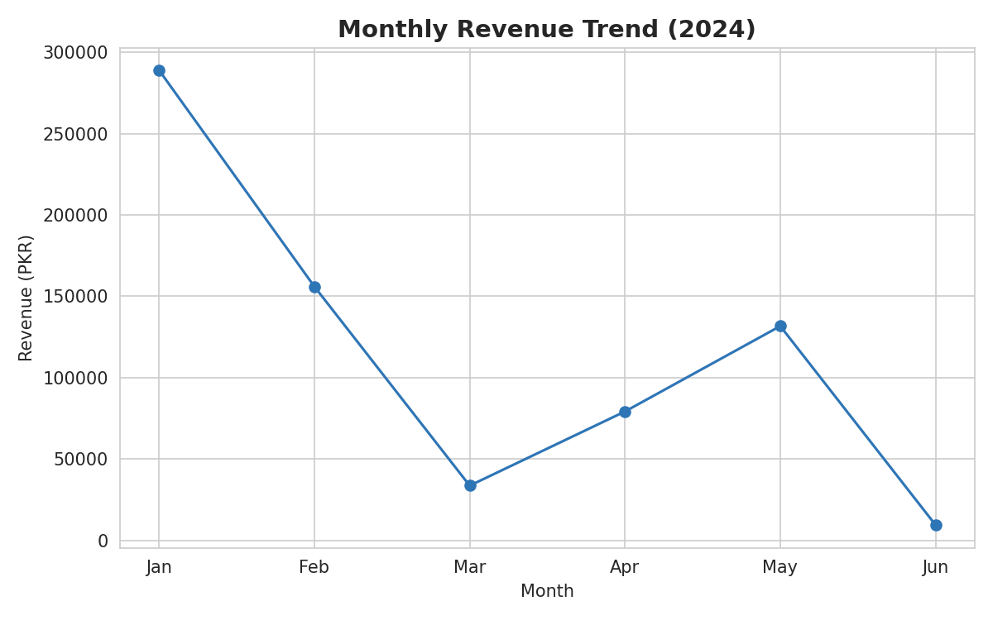

5. Product-Wise Performance
Revenue and unit sales were aggregated for each of the 12 products. Electronics items (Laptop, Smartphone) dominate revenue due to high unit prices, even though products like Notebook Set and T-Shirt sell in higher unit volumes.
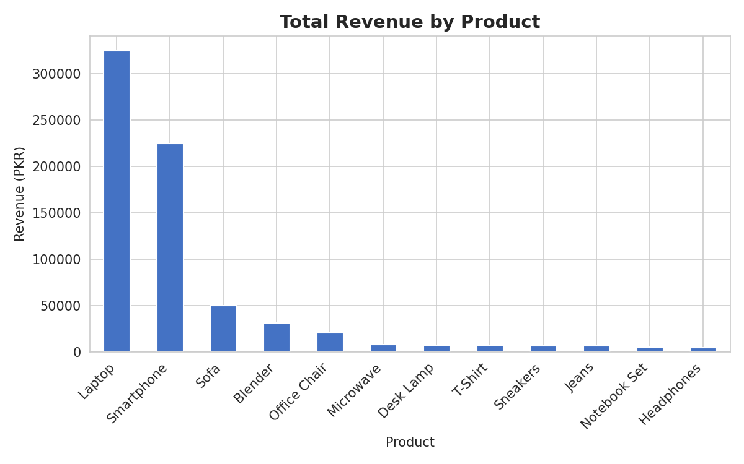

6. Best- and Least-Selling Products
Metric | Product | Value
Best-seller by revenue | Laptop | PKR 325,000.00
Least-seller by revenue | Headphones | PKR 5,000.00
Best-seller by units sold | Notebook Set | 18 units
Least-seller by units sold | Microwave | 1 unit

This highlights an important distinction: high-revenue products aren't always high-volume products. Laptops generate the most revenue due to their high price point, while Notebook Sets move the most units but contribute relatively little revenue.

7. Category-Wise Comparison
Electronics is by far the dominant category, contributing roughly 79% of total revenue, followed by Furniture (~10%). Apparel and Stationery, despite reasonable unit sales, contribute a small share of total revenue due to low price points.
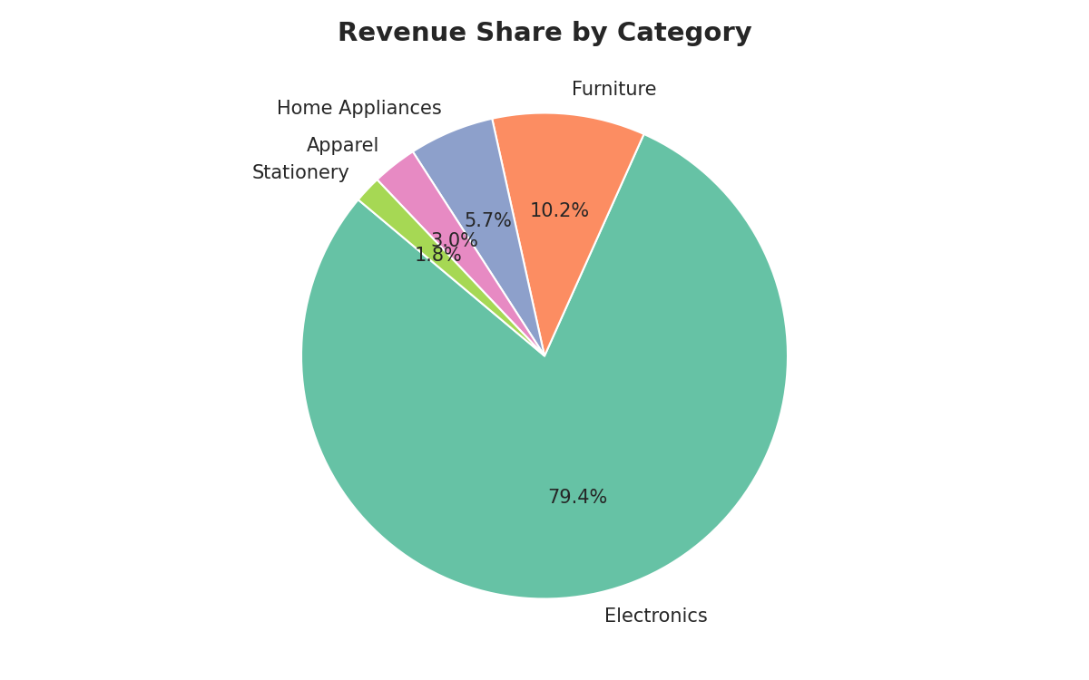

8. Regional Sales Comparison
The North region leads significantly in revenue (~55% of total), driven largely by two high-value Laptop orders. West and South follow at a distance, while East lags noticeably behind the other regions.
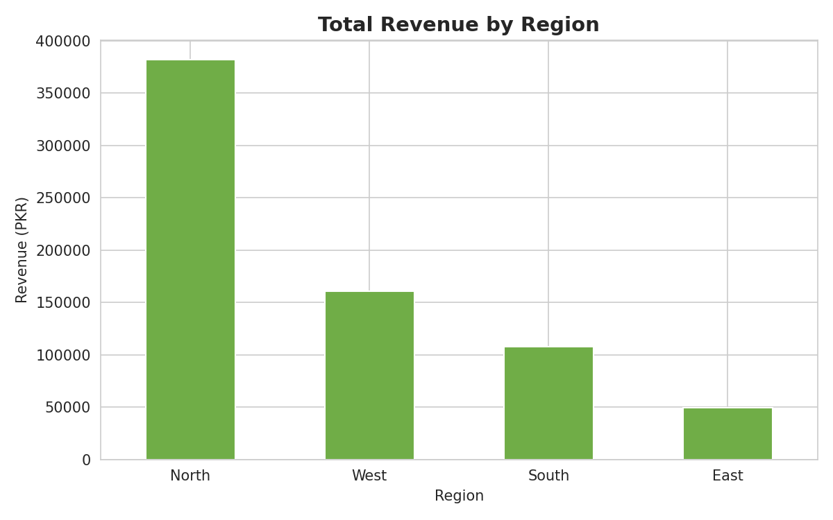

9. Key Business Insights
- Electronics is the revenue backbone of the business, contributing ~79% of total revenue from just 3 of 12 products (Laptop, Smartphone, Headphones).
- Laptops alone generate ~46% of total revenue - the single most important product for the business.
- Furniture is the second-largest category (~10% of revenue), driven by Sofa and Office Chair.
- High-volume, low-value items (Notebook Set, T-Shirt, Desk Lamp) sell consistently but contribute under 3% of revenue combined - useful for footfall/cross-selling but not core revenue drivers.
- Headphones and Microwave are the lowest revenue generators - candidates for bundling with related Electronics/Appliance purchases.
- January is the strongest month, largely due to a single high-value Laptop order; June is the weakest month of the period.
- North region dominates revenue (~55%), mainly due to two large Laptop orders going to that region - this concentration is a risk if those customers churn.
- East region underperforms significantly (~7% of total revenue) - a priority area for sales/marketing investment.
- Average order value (PKR 36,784) is heavily skewed upward by big-ticket Electronics purchases; most other orders are well below this average.
- Data quality issues (1 duplicate, missing values, 1 negative quantity, inconsistent region naming) were present in roughly 25% of records - indicating a need for stronger input validation at the point of sale, even at small scale.

10. Conclusion & Business Recommendations
This small dataset illustrates the same dynamics likely to appear at larger scale: heavy reliance on a small number of high-value Electronics products and concentration of revenue in one region. While the sample size is too small for statistically robust conclusions, the workflow demonstrated here - cleaning, exploring, visualizing, and extracting insights - scales directly to larger datasets.
Recommendations:
- Track high-value customers (e.g. those purchasing Laptops) closely, as a small number of orders disproportionately drive revenue.
- Investigate why East region has low order volume and revenue, and consider targeted promotions there.
- Bundle low-revenue accessories (Headphones, Notebook Sets) with higher-value Electronics purchases to increase average order value.
- Implement data validation rules at the point of sale (no negative quantities, standardized region dropdowns, mandatory price fields) to reduce future data cleaning effort.
- Collect more data over a longer time period to validate whether the January spike and June dip are genuine seasonal patterns or one-off events.

11. Tools Used
- Python: Pandas and NumPy for data cleaning and analysis
- Matplotlib and Seaborn for visualizations
- Deliverables: sales_data_raw.csv, sales_data_cleaned.csv, analysis.py, and this report

